DEVELOPING A MODEL FOR SMART LEARNING IN SECONDARY EDUCATION IN THE UAE

FAISAL ABDULLAH SAEED AL-NAQBI
SULTAN IDRIS EDUCATION UNIVERSITY

ABSTRACT
To investigate the outcome of implementing smart learning in UAE secondary schools, this study aimed at exploring the influence of the smart environment (SE) and smart pedagogy (SP) on smart learners’ performance (SLP). The independent variables in this study are SE, whose dimensions are Smart Technology (ST), Environment (E), Control (C), and Group Interaction (GI) and the Smart Pedagogy (SP) whose dimensions are Understanding (U), Critical Thinking (CT), Learning Skill (LS), and Smart Intelligence (SI). The dependent variable is Smart Learner’s Performance (SLP). Besides, the study aimed at developing a model for smart learning in UAE secondary schools. The method used in the research was a quantitative research methodology, with random sampling. Also, a 7-Likert scale questionnaire was developed for a sample size of 347 respondents. Three statistical methods, including independent t-test, correlation, and multiple regression were used for the analysis of results. The results of the research indicate that the hypothesis relating to SE and SP were supported and significantly affected SLP. Another investigation was the effects of SE on SE, which found out that they mutually influenced each other significantly supported. The results have shown that five hypotheses of ST, GI, CT, LS, and SI were supported and significantly affecting SLP. Hypotheses that were not supported in the study are E, C, and U. Based on the results, five models were developed with a statistical significance of 64.9%. Conclusions of the research indicated that the implementation of smart learning in UAE secondary schools was successful.

1.0 NTRODUCTION
Technological advancements in the last three decades have prompted the adoption of new techniques in education. Modernization, today can be witnessed in both public and private organizations. Similarly, learning institutions have embraced the use of modern technologies called smart technology (Galil, 2014). The development of ICT in education over the years has led to the development of a new structure and methodology for the principles of education (Robin, 2016). Smart learning is a new technique that has been developed to help improve teaching and learning outcomes. Smart learning is linked with attributes like innovation, decision-making, effectiveness, and efficiency. According to Spector (2014), a smart learning environment is made up of learners, teachers, and members of the community. Today, smart learning is considered an essential feature in education in developed and developing nations.
It is a technology that has been used in the country since 2012 at all levels of education. The ministry of education in the UAE has the responsibility of introducing a smart learning environment in all learning institutions by 2020 under the AUAE 2022 vision (Alhebsi et al., 2015). Since the introduction of the concept in Dubai in 2012, it has been rapidly adopted across the nation and considered an essential need to promote education and address the basic needs of all stakeholders.
1.1 Education System in UAE: Historical Perspective and Evolution
The UAE, made of seven states was formed in 1971 with the joining state of Ras Al Khaimah (Smith, 2014). Even before the formation of the country, the traditional education system was being used. The traditional system was made of four categories, including Mutawa (education for preparing religious Imams who teach the Koran and Islamic studies), Katateeb (physical places similar to schools where teachers are teaching the youth Koran along with writing, reading, and mathematics), Educational Circles (special circles where religious scholars teach Koran, Arabic, the foundations of the Islam, and history), and Semi-structured Schools (educational institutions that teach Arabic, Koran, social studies, and mathematics). The traditional system was used between 1907 and 1953, after which the categories were integrated into the government-led systems (Alhebsi et al. 2015).
Education in the UAE has passed through three periods. The first period was from the introduction of the traditional education system in 1907 to 1976. Education during this period was private and was provided on an elementary basis. The second period is 1976 to 2005 and was characterized by an institutionalized education system established by the ministry of education (MOE). The Abu Dhabi Education Council (ADEC) was established to act as the professional organization for managing education in Abu Dhabi the largest emirate in the nation. The third period began in 2005 to date, when smart learning was established. Since 2005, smart learning techniques in all tertiary educational institutions have been used to enhance the provision of quality and education.
Since the onset of education in the UAE in the 19th century, rapid transformations have been experienced. However, as a result of internal and external factors affecting the region, there have been periods of stagnation. Despite the stagnations, the establishment of MOE and regulation of education by the government has helped improve learning and transfer of knowledge. Further transformations have been realized from 2012, following the introduction of modern learning technologies. The introduction of these modern technologies is inspired by the 2022 UAE vision, to become a knowledge-based nation through the integration of technology in education and other fields. The use of modern technologies has helped revolutionize the culture of education; the new culture is characterized by smart classes. To achieve this vision, the country has introduced an initiative to provide students with electronic tablets with 4G speeds.
1.2 Integration of Smart Learning in UAE Education System
. Spector (2014) defines smart learning as knowledge or skills acquired through instruction, study, and experience with the aid of smart technology. The three elements, i.e., instruction, study, and experience can be considered the framework of any educational system. Smart learning can also be defined as the ability of a learner to acquire knowledge and skills using smart technologies without relying on conventional methods of learning (Jukes, 2008). The smart learning approach involves the use of computers that are run by 4G high -speed networks. Teachers, on the other hand, have laptops installed with all teaching materials. Therefore, smart learning can be defined as the process of learning with the aid of electronic devices, which provide visual and audio output.
The transformation process from traditional to modern learning approaches is complex, needing the consideration of acronyms, abbreviations, and technologies. Woollard (2011) states that having a well-trained team to help in the transformation is essential for learners, teachers, and administrators. All stakeholders should know operating electronic devices, using the internet, and other technology-based devices.
Although smart learning has numerous benefits, there are several concerns, including prompting stakeholders to adopt the technologies, available resources, and finding quality technologies (Sumbul & Faisal, 2018). In the United States and some European countries, the introduction of smart learning in 1991 was dependent on factors like the knowledge and skills of teachers and their cumulative experience (Russel et al., 1991). The research conducted by Russell and his colleagues shows the role of educators towards the success of using e-learning. Another challenge is additional costs incurred at the national level, the inability to craft an effective vision, the presence of different stakeholders who face diverse challenges using new technologies, and approaches to monitoring and assessing the performance of learners (Evans, 2016).
1.3 Research Problem
Smart learning in the UAE has been implemented at all learning levels, from primary to graduate levels. Changing to modern learning approaches is a practical and theoretical process, which is faced with numerous problems. These issues are related to traditional learning styles and the problem of compromising the future of young learners (Ouadoud et al., 2016). Integration of smart learning in the country is faced by challenges associated with cost, school capacity, and the inability of teachers to adopt new technologies (Ouadoud et al., 2016). Smart learning is associated with costs from installing new technologies, new classrooms, labs, and maintenance of electronic devices and systems. The size of classes is also an issue because of installed systems, which require a certain seating. Educators can also be rigid to changes, clinging to traditional learning approaches.
According to Joseph et al., (2013), challenges facing the adoption of smart learning technologies can be grouped into six categories. Category one is related to institutions running smart education, including administration, student’ services, and academic issues. Category two is related to the maintenance of information using new technologies. Category three involves the principles of teaching and learning. Category four is related to diversity issues. Category five is related to resources to be used with the new technologies and category six involves the ability of the UAE government to use smart learning and promote education.
1.4 Research Objectives
This research will focus on achieving the following objectives.
- To determine the effect of a smart environment (SE) on smart learners'' performance (SLP) of the students in secondary schools in UAE.
- To determine the effect of smart pedagogy (SP) on smart learners’ performance (SLP) of the students in secondary schools in UAE.
- To investigate whether there is any significant correlation between smart environment (SE) and smart pedagogy (SP).
- To investigate whether there is any significant difference between private and public secondary schools in the UAE in terms of smart learners' performance (SLP).
1.5 Research Questions
- What is the impact of the smart environment (SE) on smart learners’ performance (SLP) of the students in secondary schools in UAE?
- What is the impact of the smart pedagogy (SP) on smart learners’ performance (SLP) of the students in secondary schools in UAE?
- Is there a significant correlation between smart environment (SE) and smart pedagogy (SP)?
- Is there a significant difference between public and private secondary schools in the UAE, in terms of their smart learners' performance (SLP)?
1.6 Hypothesis
The proposed hypotheses that are used to test the relationships in the conceptual framework shown in the preceding section are displayed in Table 1. Details of the process of hypothesis development are discussed in the literature review.
Hypothesis Code | Hypothesis Statement
H1 | Smart environment (SE) has a significant relationship with smart learners’ performance (SLP).
H-1a | Smart technology has a significant relationship with smart learners’ performance.
H-1b | The environment has a significant relationship with smart learners' performance.
H-1c | Control has a significant relationship with smart learners’ performance.
H-1d | Group interaction has a significant relationship with smart learners’ performance.
H2 | Smart pedagogy (SP) has a significant relationship with smart learners’ performance (SLP).
H-2a | Understanding has a significant relationship with smart learners’ performance.
H-2b | Critical thinking has a significant relationship with smart learners’ performance.
H-2c | Learning skills has a significant relationship with smart learners’ performance.
H-2d | Smart intelligence has a significant relationship with smart learners’ performance.
H3 | There is a significant correlation between smart environment (SE) and smart pedagogy (SP).
H4 | There is a significant difference between private and public secondary schools in the UAE, in terms of smart learners’ performance.

1.7 Scope of study
The study is conducted in the UAE where the implementation of smart learning is crucial. The study targets high school education, which consists of three years out of the 12-year introductory education (i.e., grade-10, Grade-11, and Grade-12). Three subjects are explored, including English, sciences, and mathematics. A quantitative research approach is used to investigate a model of smart learning.

2.0 LITERATURE REVIEW
According to Smith (2004), UAE was formed in 1972, a period when traditional teaching techniques were used to teach the Koran and religious matters. To improve education and promote quality learning, the MOE was established. Using modern learning techniques today proves the transformation of the country to match other developed countries. The research conducted in this context is based on a high school that is run by the MOE. The geographic location of the UAE is shown in figure 1 below, where 80% of the country is a desert. Despite being a desert, the country is one of the richest in the world following the discovery of oil in the 1970s. In addition to oil, the economy of the country is driven by tourism, which by a large percentage is driven by increased attainment of education. In addition to a strong economy, the country has focused on modernizing government agencies, political systems, civil agencies, and education systems (Alhebsi et al., 2015).
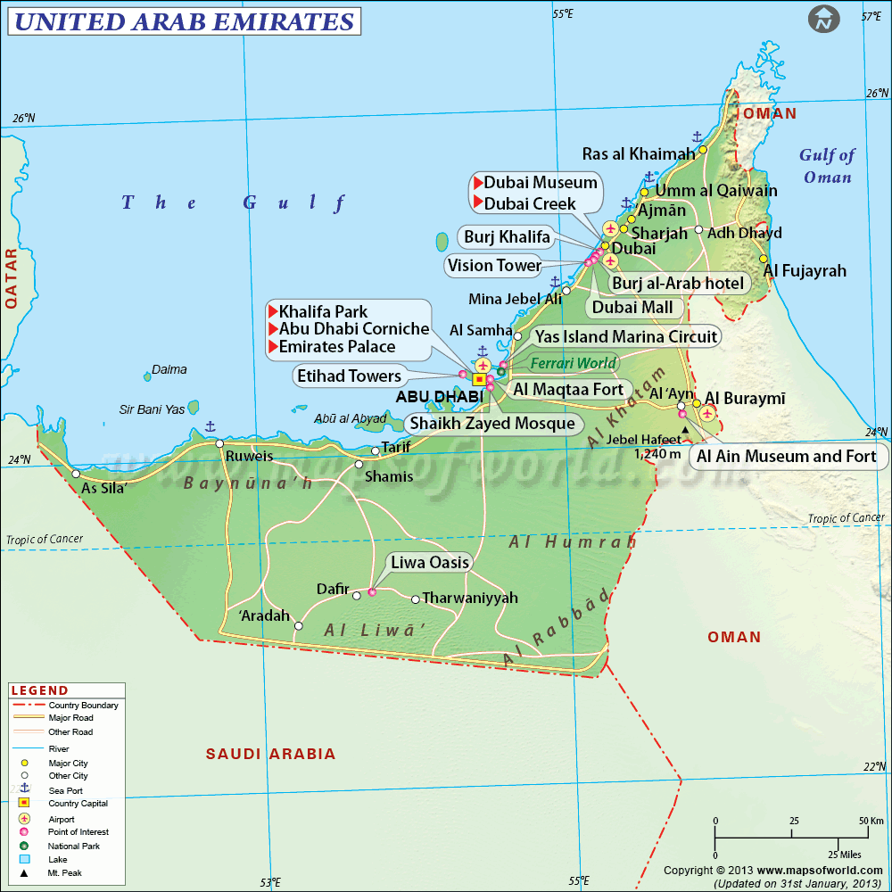
Figure 1. The United Arab Emirates and Neighboring Countries.
Numerous researches have been conducted over the decades to determine the performance of students and their learning outcomes. Research shows that introduction of modern technologies has improved students' learning, thinking, performances, and proficiency in learning. Also, learning using modern technologies has shown major differences compared to those using traditional learning methods (Grynkewich, 1995). Another study by Chen & Chen (2018) shows that using modern learning technologies makes students have higher performances. Compared with those using traditional learning techniques, students using smart learning show higher performances (Lang et al., 2018).
In the UAE, smart learning (also referred to as e-learning) was established throughout the country ensuring the availability of this education system to all, regardless of their ages, genders, or nationalities (Alhebsi, 2015). The use of smart learning techniques in the UAE has improved teaching and learning processes, giving learners the ability to develop effective schedules, able to access information timely, and access to all learning materials. Shifting from the use of traditional methods has helped improve the level of education in the country compared to that in developed nations. The UAE’s education is free for all Emiratis. The primary, middle, and high school are considered the basic primary education of 12 years period. The curriculum is developed to serve the promising developments in the UAE. Arabic is an essential language while English is the second. The higher education institutions in the UAE continue to improve in QS rankings, by showing improvement in teaching and research. The improvement in the field of education was a direct result of the volume of spending in this field since the year 2011.
The implementation of smart learning in the UAE was started by the Finnish government, which sought to improve education depending on cultural and religious foundations in the country. Exportation of the Finnish educational system in the country helped in the restoration of teaching and learning in the country. The Finish government focused on training educators, providing a suitable system, educational components, and monitor the implementation of the system.
2.1 Secondary School Education in the UAE
All citizens in the nation are required to get an education since the 1970s. Due to a rapidly growing population, the government has tried to adopt the use of smart learning techniques. The use of smart learning in the country has been prioritized over other issues in the country (ADEC, 2017). The use of ICT in the country has helped achieve the educational goals of the country, as well as UAE vision 2022. ADEC has prioritized education in six areas as shown in figure 2 below.
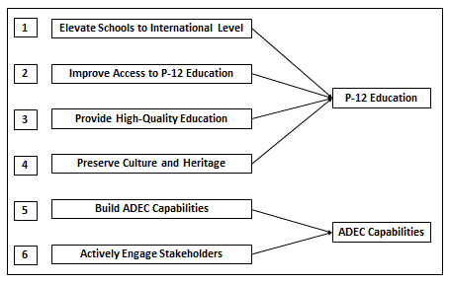
Figure 2. The 6 Priorities of ADEC towards Vision 2030 (ADEC, 2012).
Education in the country has progressed significantly as shown in figure 3 below.
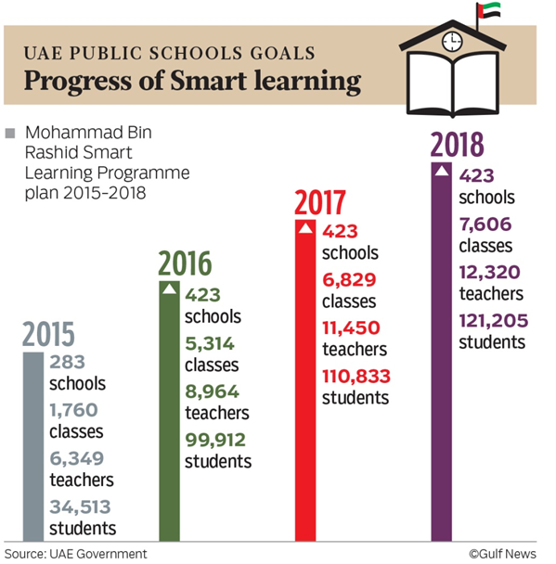
Figure 3. Progress of Smart Learning in UAE Schools (ADEC, 2012).
2.3 The Transformation from Traditional to Smart Learning
Traditional and modern educational differences portray major differences, particularly in the achievement of different layers of education. The layers of education in this case are information, knowledge, learning, and wisdom. Smart learning approaches these layers from a different perspective because it covers students, parents, teachers, and administrators (Zhu et al., 2016).
Smart education in the UAE deals with 14 communication tools as illustrated in Table 2. The table shows the weight of each of these 14 tools with the number of respondents and the percentage. The information shows that the use of cell phones indicates the highest number of respondents (56) that is 93% of the respondents reported that they use these devices. On the other hand, Proxima has the lowest use that is only 16.12% of the respondents use this system.

Table 2. Communication Tools used in the UAE
No. | Electronic Communication | Respondents | Percentage
1 | Cellphone and mobile phone | 56 | 93.00%
2 | Chatroom | 19 | 31.67%
3 | Radio | 29 | 84.33%
4 | Television | 49 | 81.67%
5 | VCR | 6 | 19.35%
6 | Satellite dish | 13 | 21.67%
7 | Digital camera | 32 | 53.33%
8 | E-commerce website | 12 | 20.00%
9 | Banking kiosk or money card | 10 | 32.25%
10 | Internet listserv | 8 | 22.85%
11 | Internet bulletin board | 4 | 13.33%
12 | Email account | 8 | 10.00%
13 | Voicemail | 8 | 25.80%
14 | Proxima (presentation device) | 5 | 16.12%

2.4 Smart Learning and Smart Pedagogy
The goal of a smart learning environment is to provide self-learning, self-motivated and personalized services in which learners can attend courses at their own pace and can access the personalized learning content according to their difference (Kim et al. 2013). Koper (2014) proposed that smart learning environments are defined as physical environments that are enriched with digital, context-aware, and adaptive devices, to promote better and faster learning. Smart pedagogy involves the use of content, methods, and practices for a smart learning environment. The practice includes the use of advanced technology such as teaching robots that are now being deployed in several schools in the Middle East, Asia, North America, and many European countries. The language robot is equipped with software that enhances students' understanding and encourages them to acquire learning skills. The robot also facilitates the link between students and teachers showing the best methods for children's engagement in the learning process (Liubiniene & Kasperaviciene, 2019). Smart pedagogy focuses on the integration of smart technology into the education process, which is different from the concepts of mobile learning or ubiquitous learning where the focus is primarily on Internet technology (Budhrani et al., 2018).

3.0 METHODOLOGY
The design of the research depends on the choice of quantitative methodology. A relevant proposal is suggested with a methodology that explores the design needed to conduct this study. The research design is shown in Figure 3.
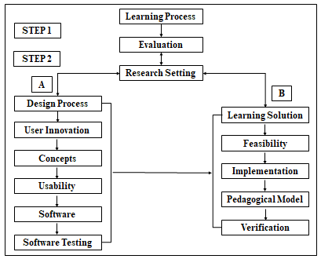
Figure 3. The Research Design
The approach that will be used for this research is a quantitative research design. Based on the large data set, the quantitative methodology provides better and more reliable analysis. Another reason for choosing the quantitative methodology is the appropriateness of the analysis for standard comparisons wherever it is needed. Validity determines the ability of the collected data to capture the investigation process of the outcome (Ghauri & Gronhaug, 2020). The types of validity include face validity, content validity, construct validity, and criterion validity.
There are 4 cut-offs points for reliability:
0.90 and above (excellent reliability)
0.7-0.9 (high reliability)
0.5-0.7 (moderate reliability)
0.5 and below (low reliability).
The study sample was selected randomly from those schools and the study sample consisted of five public schools (3235 students) and three private schools (1794 students) with a total number of 5029 students from high schools in UAE. This study applied a self-administered survey questionnaire in collecting the data. A pilot study was conducted one month before the commencement of the actual data collection. Convenience sampling was used in selecting the sample in the pilot study.

4.0 RESULTS AND FINDINGS

Table 4. Secondary Schools (Sampling Frame)
School Name | Type | Boy/Girl/Mixed | Students
Al Maqam Secondary School | Public | Boys | 654
Mariam Bint Sultan School | Public | Girls | 623
Um–Al Emirates Secondary School | Public | Girls | 682
Khaled Bin Al Waleed School | Public | Boys | 647
Aljahli High School | Public | Boys | 629
Total number of students in public schools |  |  | 3235
Al Dhafra Private Schools | Private | Mixed | 655
The Gulf International Private Academy | Private | Boys | 707
Brighton College | Private | Mixed | 432
Total number of students in private schools |  |  | 1794
Total |  |  | 5029
368 questionnaires were obtained. 5 questionnaires were untouched, 9 questionnaires had two unanswered sections, seven questionnaires were missing between 4 and 6 sections. Excluded questionnaires were 21 with 347 being usable. The number of eligible students in public schools is 219 (63.1%) while the net number of students in private schools is 128 (36.9%).
Table 5 Normality test in terms of Skewness and Kurtosis
Variable | N | Mean | Stand Dev | Skewness |  | Kurtosis
 |  |  |  | Statistics | Std Dev | Statistics | Std Dev
ST | 347 | 5.49 | 1.132 | -1.313 | 0.131 | 1.434 | 0.261
E | 347 | 5.53 | 1.310 | -1.324 | 0.131 | 1.572 | 0.261
C | 347 | 5.29 | 1.353 | -0.932 | 0.131 | 0.332 | 0.261
GI | 347 | 5.42 | 1.237 | -0.893 | 0.131 | 0.551 | 0.261
U | 347 | 5.28 | 1.413 | -0.934 | 0.131 | 0.364 | 0.261
CT | 347 | 5.56 | 1.386 | -0.822 | 0.131 | 0.411 | 0.261
LS | 347 | 5.73 | 1.401 | -0.950 | 0.131 | 0.539 | 0.261
SI | 347 | 5.33 | 1.440 | -0.919 | 0.131 | 0.347 | 0.261
S | 347 | 5.51 | 1.418 | -0.942 | 0.131 | 0.534 | 0.261
K | 347 | 5.31 | 1.397 | -0.998 | 0.131 | 0.661 | 0.261
I | 347 | 5.26 | 1.360 | -0.866 | 0.131 | 0.682 | 0.261
EI | 347 | 5.25 | 1.437 | -0.958 | 0.131 | 0.497 | 0.261
SE(IV) | 347 | 5.44 | 1.112 | -1.110 | 0.131 | 0.753 | 0.261
SP(IV) | 347 | 5.21 | 1.270 | -0.902 | 0.131 | 0.524 | 0.261
SLP(DV) | 347 | 5.29 | 1.243 | -0.904 | 0.131 | 0.768 | 0.261
Valid N | 347

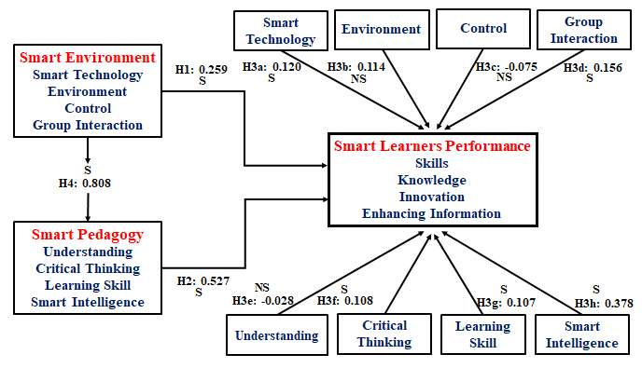
Figure 4. Standardized $β-Values$ of Relationships between Variables
The $β$ –the value of 0.527 in H-2 shows that smart pedagogy (SP) has a stronger relationship with SLP. The $β$ -value is 0.259 in H-1, which is lower than that of H-2. There is an insignificant relationship between understanding and SLP. There is a strong correlation between SE and SP in H-3, where $β=0.808)$. The data shows that there is a significant difference between the mean values for the 128 private schools and the 219 public schools.
Table 6. Summary of Statistical Results
Hypothesis | Relationship | Path ($β$) | t-value | Sig. | Direction | Decision
H-1 | SE $→$ SLP | 0.259 | 3.883 | 0.000 | Positive | Supported
H-1a | ST $→$ SLP | 0.120 | 2.187 | 0.029 | Positive | Supported
H-1b | E $→$ SLP | 0.114 | 1.951 | 0.052 | Positive | Not Supported
H-1c | C$→$ SLP | -0.075 | -1.148 | 0.252 | Negative | Not Supported
H-1d | GI $→$ SLP | 0.156 | 2.526 | 0.012 | Positive | Supported
H-2 | SP $→$ SLP | 0.527 | 7.896 | 0.000 | Positive | Supported
H-2a | U $→$ SLP | -0.028 | -0.443 | 0.658 | Negative | Not Supported
H-2b | CT $→$ SLP | 0.108 | 1.792 | 0.014 | Positive | Supported
H-2c | LS $→$ SLP | 0.107 | 1.712 | 0.008 | Positive | Supported
H-2d | SI $→$ SLP | 0.378 | 5.554 | 0.000 | Positive | Supported
H-3 | SE SP | 0.808 | 2.594 | 0.040 | Positive | Supported
H-4 | The statistical difference between mean-values of SLP, for both private and public schools in UAE, were found to be significant. |  |  |  |  | Supported

The four main hypotheses are H1, H2, H3, and H4. There are eight sub-hypotheses, i.e., H-1a, H-1b, H-1-c, H-1d, H-2a, H-2b, H-2c, & H-2d.

Table 7. Summary of Hypotheses Testing
Code | Hypotheses Statement | Result of Hypotheses Test
H-1 | A smart environment has a significant and positive relationship with smart learners’ performance. | Supported
H-1a | Smart technology has a significant and positive relationship with smart learners’ performance. | Supported
H-1b | The environment has a significant and positive relationship with smart learners’ performance. | Not Supported
H-1c | Control has a significant and positive relationship with smart learners’ performance. | Not Supported
H-1d | Group interaction has a significant and positive relationship with smart learners’ performance. | Supported
H-2 | Smart pedagogy has a significant and positive relationship with smart learners’ performance. | Supported
H-2a | Understanding has a significant and positive relationship with smart learners’ performance. | Not Supported
H-2b | Critical thinking has a significant and positive relationship with smart learners’ performance. | Supported
H-2c | Learning skills has a significant and positive relationship with smart learners’ performance. | Supported
H-2d | Smart intelligence has a significant and positive relationship with smart learners’ performance. | Supported
H-3 | There is a significant correlation between smart environment (SE) and smart pedagogy (SP). | Supported
H-4 | There is a significant difference between smart learners’ performance of students in private and public secondary schools in the UAE. | Supported

The three main relationship hypotheses are SE to SLP (H-1), (ii) SP to SLP (H-2), and (iii) correlation between SE and SP (H-3). Hypothesis H-4 shows that there is a significant difference between private and public secondary schools in the UAE.
5.0 DISCUSSIONS AND CONCLUSION
The findings of this research show that the five objectives of the research were achieved. The first hypothesis tested in the research framework posits that a smart environment has a positive and significant influence on smart learners' performance. The results indicated that the hypothesis is supported. The construct, smart environment comprises of four components smart technology, environment, control, and group interaction. A closer examination of the statistical results suggests that two of the dimensions of SE (i.e., smart technology and group interaction) have a significant impact on SLP, while the other two dimensions (i.e., environment and control) do not have a significant influence on SLP.
The second hypothesis tested in the research framework posits that smart pedagogy has a positive and significant influence on smart learners' performance. The results indicated that the hypothesis is supported. The construct, smart pedagogy comprises four components understanding, critical thinking, learning skills, and smart intelligence. A closer examination of the statistical results suggests that three of the dimensions of SP (i.e., critical thinking, learning skills, and smart intelligence) have a significant impact on SLP, while the other dimensions (i.e., understanding) does not have a significant influence on SLP.
The third hypothesis posited in the research framework for this study suggests that both smart environment and smart pedagogy are correlated. Therefore, the findings of this study are consistent with the rationale presented in the previous paragraph. Furthermore, this result is also aligned with the discoveries made by Zhu et al. (2016), where part of the framework explores the relationship between a smart learning environment and smart pedagogy.
The results of group comparison in terms of smart learners' performance of private and public secondary schools in the UAE show that there is a significant difference between the two groups of students. The higher score obtained by the students in the private schools suggests that the elements and the construct of a smart environment, smart pedagogy have a higher influence on the students in the private schools which was reflected in the performance of the students in the private schools. The results of the hypotheses test show that the difference in the mean scores of 128 private school students was higher than the mean-scores of SLP in the 219 public schools. The difference was also found to be statistically significant.
6.0 Limitations of the Research
Limitations include the use of participants from secondary schools in Abu Dhabi, presence of cultural traditions limiting access of information from female respondents, lack of interactive learning environment, and the use of cross-sectional study where all responses were gathered at the same time.
7.0 Recommendations for Future Research
Future research may consider adopting the technology acceptance model (TAM), which was proposed by Davis et al. (1989) and has been tested in numerous contexts with different technologies and populations. Also, it is recommended that the education innovation grid established by Roumen & Kovatcheva (2017) may help in shedding more light on the educational procedure and, in particular, the smart learning process. Another recommendation may arise from the smart learning model which should be re-tested with a different sample such as a sample of teachers with multiple schools around the region and other countries as benchmarking standards. Lastly, future researchers may investigate the feasibility, effectiveness, and viability of the smart learning model and outcome of performance in terms of longitudinal studies. A longitudinal study should test and retest the model until it becomes stable within at least 5 years (Chamorro, Premuzic & Furnham, 2003).
8.0 Conclusion
This research aimed to develop a model of smart learning and to explore quantitatively the effects of smart pedagogy and smart learning environment in bringing success to the smart learners' performance in schools in the UAE. The study also focused on examining the relationships between Smart Environment and Smart Pedagogy. Lastly, the results of this research indicate that the private schools in UAE are experiencing more effectiveness in achieving smart learning performance of learners, compared to the public schools. This may be an avenue for policymakers to look into, to bring more equity in access to education.
The research has discovered useful information that can be of importance to key stakeholders in the UAE. When assessing the relationship between smart learners' performance and its antecedents, it was concluded that smart pedagogy was most essential. The government-led initiative has laid great stress in investing in the establishment of a smart learning environment. However, without a substantial focus on pedagogy development that works in tandem with the smart environment, the goals of the government in achieving high levels of smart learning performance in schools, may derail targets.

References
ADEC (2012). The foundation of the new school model: teacher’s guidebook. Retrieved from: https://www.adec.ac.ae/en/mediacenter/publications/teachers-guide-partA.pdf.
ADEC (2015). ADEC public school manual. (2015, March 28) Retrieved from https://portal.adec.ac.ae.
ADEC (2017). Education in Abu Dhabi. https://www.adek.abudhabi.ae/en/AboutADEC/Pages/default.aspx.
Alhebsi, A., Pettaway, L. D., and Waller, L. (2015). A History of Education in the United Arab Emirates and Trucial Sheikdoms. The Global e-Learning journal, Vol. 4(1), pp. 1-6.
Budhrani, K., Ji, Y., & Lim, J. H. (2018). Unpacking conceptual elements of smart learning in the Korean scholarly discourse. Smart Learning Environments, 5(1), 23-49.
Chamorro‐Premuzic, T., & Furnham, A. (2003). Personality traits and academic examination performance. European Journal of Personality, 17(3), 237-250.
Galil, T. E. A. (2014). The Mohammed bin Rashid's Smart Learning Program (SLP) Initiative in the Ministry of Education and its impact on English language performance in Cycle2 Classes, in the United Arab Emirates (UAE) (Doctoral dissertation, The British University in Dubai (BUiD)).
Joseph, C., Thomas, M., Simonette, G., and Ramsook, L. (2013). The Impact of Differentiated Instruction in a Teacher Education Setting: Successes and Challenges. International Journal of Higher Education Vol. 2, No. 3; pp. 28-40.
Jukes, I. (2008). Understanding digital kids: Teaching and learning in the new digital landscape. Retrieved March 10, 2010, from ttp://www.hmleague.org/Digital%20Kids.pdf
Liubinienė, V., & Kasperavičienė, R. (2019). Children’s Empowerment Through Digital Technologies in the Context of Smart Pedagogy: Case Study. In Didactics of Smart Pedagogy (pp. 253-265). Springer, Cham.
Mohammad, R. T. (2017). Assessing the quality of education in Saudi Arabia. International Journal of Economic Research, 14(17), 521–528.
Ouadoud, M., Chkouri, M. Y., Nejjari, A., & El Kadiri, K. E. (2016). Studying and Analyzing the Evaluation Dimensions of E-learning Platforms Relying on a Software Engineering Approach. International Journal of Emerging Technologies in Learning, 11(1).
Robin, B. R. (2016). The Power of Digital Storytelling to Support Teaching and Learning. Digital Education Review - Number 30, December 2016. Retrieved from http://greav.ub.edu/der/.
Roumen, E. S., & Kovatcheva, N. E. (2017). Conceptualizing of Smart Education. Online: https://www.researchgate.net/publication/320623528_Conceptualising_of_Smart_Education. Accessed 06 Feb 2018
Russell, J. Mauthner, N., Sharpe, S., and Tidswell, T. (1991). The windows tasks as a measure of strategic deception in preschoolers and autistic subjects. British Journal of Psychology, 9, 331-349.
Spector, J. M. (2014). Conceptualizing the emerging field of smart learning environment. Smart Learning Environments 2014, 1:2, pp. 2-10.
Sumbul, M., & Faisal, M. (2018). A Study Examining the Attitude of UAE Vocational Institutes Graduating Students towards Entrepreneurship. People: International Journal of Social Sciences, 4(2).
Woollard, J. (2011). Psychology for the classroom: E-learning Routledge (New York & London) ISBN 978-0-415-59093-8 135. Retrieved from http://www.routledge.com/books/details/ 9780415590938/.
Zhu, Z. T., Yu, M. H., & Riezebos, P. (2016). A research framework of smart education. Smart Learning Environments, 3(4), 1-17.

